Experiment 1
Objective 1 : To develop electromagnetic simulation models for TEM, TE and TM propagation modes in suitable microwave transmission structures.
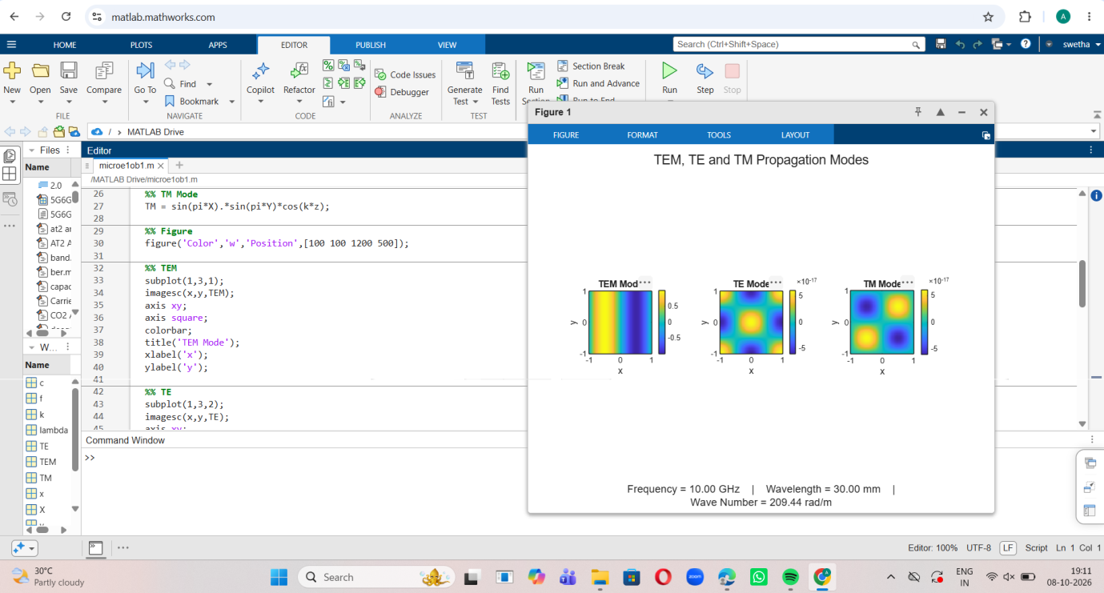
Objective 2: To visualize and analyze the electric-field and magnetic-field distributions associated with different propagation modes.

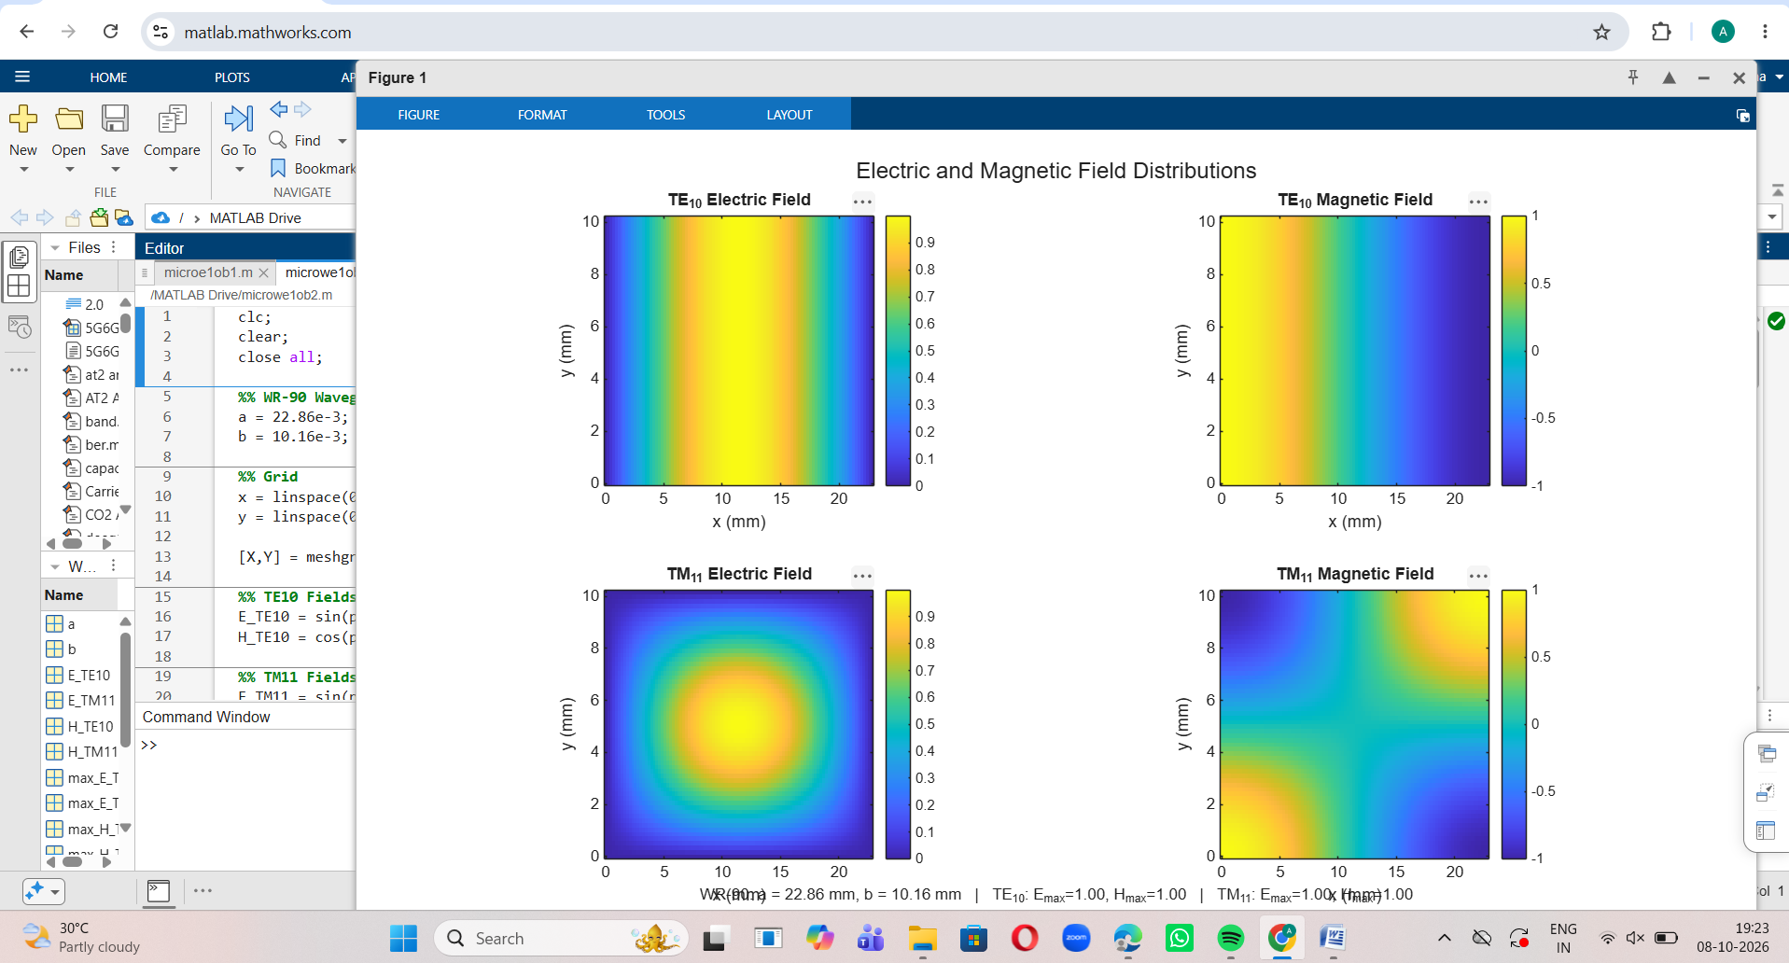

Objective 3: To determine the cutoff frequency, propagation constant and field characteristics of selected TE and TM modes.

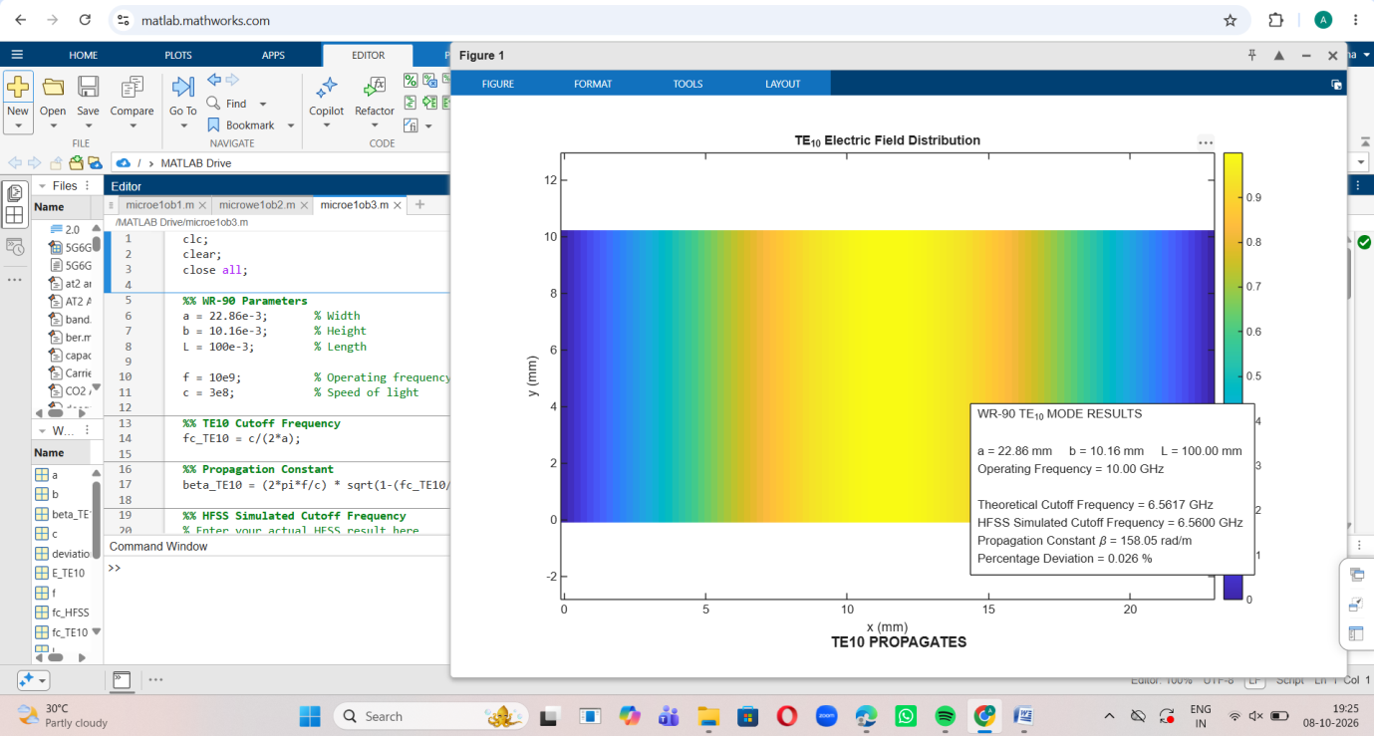

Objective 4: To compare the propagation behavior of different modes and identify their suitability for practical microwave transmission.
